2.83: a) From Eq. (2.14), with v₀=0,

b) The height above the release point is also found from Eq. (2.14), with 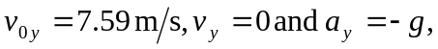
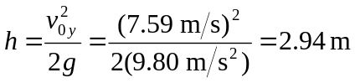

(Note that this is also (64.0 cm)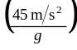.The height above the ground is then 5.14 m.
c) See Problems 2.46 & 2.48 or Example 2.8: The shot moves a total distance 2.20 m –1.83 m = 0.37 m, and the time is

